

**Physical Education Studies**

**Units 1 & 2**

**2020**

# Marking Key

**Section One – Multiple Choice**

|  |  |
| --- | --- |
| **Question** | **Answer** |
| 1 | A |
| 2 | C |
| 3 | A |
| 4 | B |
| 5 | B |
| 6 | D |
| 7 | A |
| 8 | C |
| 9 | D |
| 10 | B |
| 11 | A |
| 12 | C |
| 13 | A |
| 14 | B |
| 15 | D |
| 16 | D |
| 17 | B |
| 18 | D |
| 19 | A |
| 20 | B |

**Section Two: Short answer 50% (62 marks)**

This section has **eight (8)** questions. Answer **all** questions. Write your answers in the spaces provided. Use a blue or black pen (**not** pencil) for this section.

Supplementary pages for the use of planning/continuing your answer to a question have been provided at the end of this Question/Answer booklet. If you use these pages to continue an answer, indicate at the original answer where the answer is continued, i.e. give the page number.

Suggested working time: 70 minutes.

**Question 21 (6 marks)**

An athlete performs eight repetitions of 200 m as part of a training session. Each repetition is performed in 30 sec and is followed by 90 sec of active recovery and 3 minutes of rest between each repetition.

(a) What is the name of the training method described above?

(1 mark)

|  |  |
| --- | --- |
| Description | Marks |
| Interval training | 1 |

(b) What is the major energy system being trained?

(1 mark)

|  |  |
| --- | --- |
| Description | Marks |
| Anaerobic glycolysis/Lactic acid system | 1 |

(c) What is the major energy source fuelling each repeat sprint

(1 mark)

|  |  |
| --- | --- |
| Description | Marks |
| Carbohydrates/glycogen | 1 |

(d) Describe the principle of progressive overload and identify two (2) ways it could be applied to the training program outlined above.

(3 marks)

|  |  |
| --- | --- |
| Description | Marks |
| The planned, gradual increase in training load to ensure that fitness continues to be optimised OR  Overload is applied by only changing one variable by max of 10% | 1 |
| Any 2 of the following   * increase distance by 10% * Reduce time to complete by 10% * Reduce recovery or rest period by 10% * increase resistance offered to runner by wearing a parachute or weight bag * other relevant examples | 1-2 |

**Question 22 (6 marks)**

Task complexity influences optimal arousal levels for individuals. Tasks which are considered ‘hard or complex’ – i.e. require large amounts of information processing or movement precision vs tasks which are considered ‘easy or simple’ – i.e. require small amounts of information processing and involve gross motor movements.

Using the axis below, draw a graph that compares the optimal levels of arousal for the following activities. Label the axis as part of your response.

i) 1RM Dead lift

ii) Bowling a cricket ball

iii) Netball goal shot

iv) Rugby tackle

|  |  |
| --- | --- |
| Description | Marks |
| Correctly labelled y axis - performance | 1 |
| Correctly labelled x axis - arousal | 1 |
| Correctly labelled each activity (1 mark each) | 1-4 |

Arousal

Performance

Netball goal shot

1RM Dead lift

Bowling a cricket ball

Rugby tackle

**Question 23 (10 marks)**

Jack is ten-years-old and is performing a side foot pass in soccer at a stationary target. His technique is sometimes loose, inconsistent and displays lots of errors.

(a) What stage of skill do you believe Jack is in?

(1 mark)

|  |  |
| --- | --- |
| Description | Marks |
| Cognitive | 1 |

(b) Explain whether Jack would be aware of what is wrong and if he would know how to fix the problem.

(2 marks)

|  |  |
| --- | --- |
| Description | Marks |
| He would be aware of the outcome of his efforts and know he doesn’t always get it right. | 1 |
| However, he would have not yet developed any error detection skills to understand exactly what is going wrong | 1 |
| He will have limited understanding in how to bring about improvement in performance | 1 |

(c) For Jack to progress to the next stage of learning, feedback plays a pivotal role. Discuss the type of feedback Jack will need and how this may change as he moves to the next stage of learning.

(4 marks)

|  |  |
| --- | --- |
| Description | Marks |
| Jack requires extrinsic augmented feedback – provided from an external source such as a coach or mentor | 1 |
| It needs to be simplistic and frequent in nature (also accept positive) | 1 |
| As Jack progresses to the Associative stage, it can move to a combination of extrinsic augmented and intrinsic | 1 |
| Feedback can become more specific at this point (constructive) | 1 |

(d) Part of skill development involves the performer improving their ability to execute the given skill in a constantly changing environment. Identify two (2) activities a coach could implement to make the skill of kicking a soccer ball more open.

(2 marks)

|  |  |
| --- | --- |
| Description | Marks |
| Any 2 of the following   * Pass the ball to a moving target * Pass the ball whilst moving themselves * Incorporate a defender to apply ‘passive pressure’ prior to the pass   Any relevant examples that makes the skill/environment more open | 1-2 |

**Question 24 (4 marks)**

One of the major functions of the circulatory system is the circulation of blood around the body. During exercise, blood flow redistributes to the working muscles so that 80-90% of total Cardiac Output is directed to them.

(a) Using your knowledge of blood vessels, explain how the body achieves this.

(2 marks)

|  |  |
| --- | --- |
| Description | Marks |
| Arteries taking blood to working muscles will open up (vasodilate) to allow more blood flow to the muscle | 1 |
| Arteries taking blood to non-active areas of the body contract (vasoconstrict) to reduce blood flow. | 1 |

(b) Another major function of the circulatory system is to maintain body temperature. Using your knowledge of blood vessels, explain how the body redirects blood flow in hot conditions to help manage this.

(2 marks)

|  |  |
| --- | --- |
| Description | Marks |
| Arteries taking blood to working muscles will contract (vasoconstrict) to allow less blood flow to the muscle | 1 |
| Arteries taking blood to skin’s surface will open up (vasodilate) to increase sweat production | 1 |

**Question 25 (9 marks)**

The following question relates to the image below of a triple jumper.

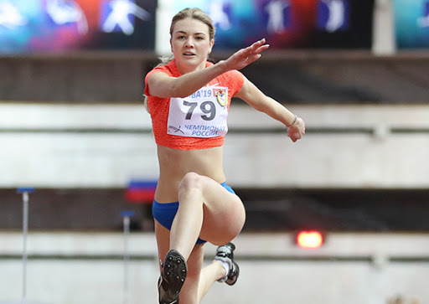

(a) Identify the three (3) articulating bones that make up the elbow joint.

(3 marks)

|  |  |
| --- | --- |
| Description | Marks |
| Humerus | 1 |
| Ulna | 1 |
| Radius | 1 |

(b) Identify the movement taking place at the athlete’s left elbow joint.

(1 mark)

|  |  |
| --- | --- |
| Description | Marks |
| Extension | 1 |

(c) Identify the agonist and antagonist responsible for the movement in (b).

(2 marks)

|  |  |
| --- | --- |
| Description | Marks |
| Agonist - triceps | 1 |
| Antagonist - biceps | 1 |

(d) Identify the articulating bones that make up the hip joint.

(2 marks)

|  |  |
| --- | --- |
| Description | Marks |
| Femur | 1 |
| Pelvis | 1 |

(e) Identify the movement taking place at the athlete’s right hip joint.

(1 marks)

|  |  |
| --- | --- |
| Description | Marks |
| Extension | 1 |

**Question 26 (6 marks)**

The following table represents a weights program for an athlete to improve their muscular strength.

Exercise Sets Repetitions Resistance

|  |  |  |  |
| --- | --- | --- | --- |
| Exercise | Sets | Repetitions | Resistance |
| Squats | 3 | 6 | 8RM |
| Bench press | 3 | 2 | 4RM |
| Dead lifts | 3 | 15 | 40%RM |
| Military press | 3 | 4 | 4RM |
| Lat pull downs | 4 | 4 | 4RM |
| Leg extension | 4 | 4 | 50%RM |

(a) To achieve improvements in muscular strength, how many times per week would the athlete need to undertake the above weights training schedule?

(1 mark)

|  |  |
| --- | --- |
| Description | Marks |
| 3-4 | 1 |

(b) In the table, what does 4RM stand for/represent?

(1 mark)

|  |  |
| --- | --- |
| Description | Marks |
| 4 repetitions maximum OR  The maximum amount of weight that can be moved 4 times | 1 |

(c) Do any prescriptions of sets, repetitions and resistance seem inappropriate to the stated goal of muscular strength improvement? Justify your answer.

(3 marks)

|  |  |
| --- | --- |
| Description | Marks |
| Strength gains requires athletes to lift near maximal RM | 1 |
| Repetitions too high for dead lifts – more muscular endurance or hypertrophy training | 1 |
| Resistance too low in dead lifts and leg extension – needs to be above 80% | 1 |

(d) In a three-month program consisting of the exercises from the table, indicate when overload should be applied.

(1 mark)

|  |  |
| --- | --- |
| Description | Marks |
| When the training sessions/resistance start to become easier – usually indicates adaptations have occurred | 1 |

**Question 27 (13 marks)**

The spin/rotation method has taken over from the glide as the preferred putting technique for shot-putters. It is believed to be the best method to enable the putter to maximise their distance.

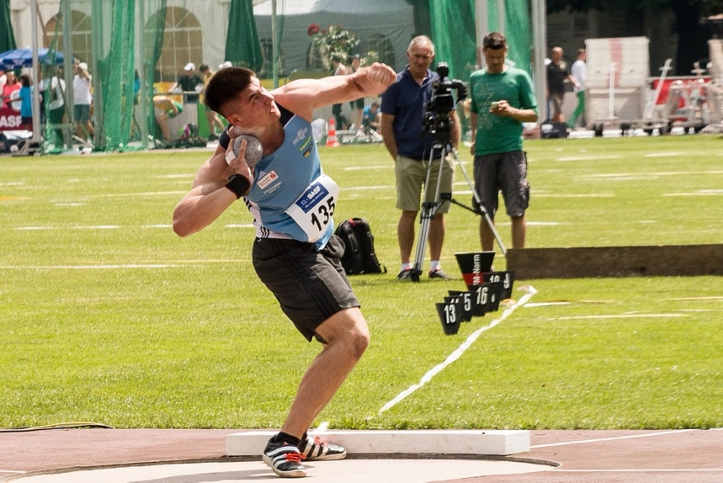

(a) Define each of Newton’s Laws and provide an example of how they apply to the shot put.

(6 marks)

|  |  |
| --- | --- |
| Description | Marks |
| 1st Law - A body continues in its state of rest or state of motion unless acted upon by a force | 1 |
| Relevant example | 1 |
| 2nd Law - The acceleration of a body is proportional to the force applied to it and inversely proportional to the mass of the object | 1 |
| Relevant example | 1 |
| 3rd Law - For every action, there is an equal and opposite reaction. | 1 |
| Relevant example | 1 |

(b) One analysts watching the event writes the following comment:

‘A direct linear relationship exists between the angle of release and the distance travelled for any given speed of release.’

Do you agree with this comment? Justify your response.

(2 marks)

|  |  |
| --- | --- |
| Description | Marks |
| Incorrect | 1 |
| As the angle of release increases, so too does the distance travelled by the shot, but this only holds true up to just below 45 degrees. | 1 |
| Any further increases in angle of release will lead to decreases in distances travelled by the shot. | 1 |

(c) Segmental interaction is a key biomechanical principle which allows for performance in the shot put to be maximised. Using the space below, draw a graph to show how the legs, torso and arms interact to build momentum and produce optimal performance.

(4 marks)

|  |  |
| --- | --- |
| Description | Marks |
| Correctly labelled axis | 2 |
| Correct sequencing of segments (legs, torso, arm) | 1 |
| Correct timing of segments (i.e. when previous reaches max velocity) | 1 |

Arms

Force

Torso

Legs

Timing

**Question 28 (8 marks)**

Nideffer’s Model of Attention determined that different sports have varying attentional requirements and viewed attentional focus along two dimensions – direction and width.

Below is a diagrammatic representation of Nideffer’s Model of Attention. Complete the diagram by labelling the axis (A-D) and describing the attentional requirements of each quadrant (1-4).

|  |  |
| --- | --- |
| Description | Marks |
| See diagram below –  1 mark for each correctly labelled axis  1 mark for each correctly described quadrant | 1-8 |

Narrow

External

Broad

**Narrow – External**

Focused targeting which is the ability to block out distractions and focus on specific cues.

**Narrow – Internal**

Focus on a specific image, thought or coaching point with few other cues.

**Broad – Internal**

Attention paid to internal thoughts and images.

**Broad – External**

Attention paid to a large number of cues in the external environment.

Internal

**End of Section Two**

**Section Three: Extended answers 30% (30 marks)**

This section contains **four (4)** questions. You must answer **two (2)** questions. Write your answer in the spaces provided.

Supplementary pages for the use of planning/continuing your answer to a question have been provided at the end of this Question/Answer booklet. If you use these pages to continue an answer, indicate at the original answer where the answer is continued, i.e. give the page number.

Suggested working time: 50 minutes.

**Question 29 (15 marks)**

The ‘Tailwind Nutrition 3 Marathons in 3 Days’ is an annual event held in far North Queensland in which a marathon is run each day over three consecutive days. Competitors can opt to compete in only one or two of the marathons, but the ‘Grand Slam’ medal goes only to those who complete all three marathons.

(a) Describe the nutritional requirements for an athlete trying to complete the ‘Grand Slam’ event. Include in your response considerations before, during and after each marathon.

(9 marks)

|  |  |
| --- | --- |
| Description | Marks |
| Before the event   * Athletes should consume 10 – 12 g of carbohydrate per kg of body mass to carbohydrate load effectively. * Low GI foods/carbohydrate are used to carbohydrate load. * CHO loading combined with exercise taper to top up glycogen supplies * Maintain fluid intake to ensure optimal hydration | 1-2 |
| Pre event meal (1-4 hrs before)   * Approx. 600ml of fluid to assist with hydration * Low GI meal to top up glycogen supplies * Avoid high fibre foods and/or avoid high fat foods. | 1-2 |
| During the event   * 200ml of fluid every 15 min * 30-60 g of CHO per hour * Carbohydrate should be high GI. * Avoid high fibre foods and/or avoid high fat foods. * Ingest electrolytes to decrease cramps/dehydration. | 1-2 |
| Immediately after the event   * High GI CHO within 30 minutes of event as muscles most responsive * Commence fluid replenishment with the goal to replace 1.5* weight loss | 1-2 |
| Next 24hrs after the event   * Ingest electrolytes to replace essential minerals and assist recovery * Consume 7-10g/kg body mass of low to moderate GI CHO * Consume protein to assist with muscle repair | 1-3 |
| **Total** | **Max 9 marks** |

(b) An individual’s concentration can be influenced by age, skill level and activity type. Describe how each of these factors impact concentration and for each factor, suggest one strategy the coach could use to help improve their concentration.

(6 marks)

|  |  |
| --- | --- |
| Description | Marks |
| Age:   * Typically, the younger the individual, the more likely they are to lose focus on a regular basis * Reduce length of drills, increase variety amongst activities and training sessions   Other relevant example | 1 mark for description  1 mark for strategy |
| Skill Level:   * Highly skilled athletes are better able to attend to relevant stimuli whilst ignoring distractions * As a result, when coaching less skilled participants, coaches must provide more predictable, closed environments, allowing the players to focus on a reduced number of stimuli * As the players become more skilled, the environment can become more open, allowing the individuals to develop the ability to filter out distractions whilst also shifting their attention from one stimulus to the next.     Other relevant example | 1 mark for description  1 mark for strategy |
| Influence of activity type   * Activities that provide constantly changing stimuli are more likely to maintain the attention and focus of an individual * This is further enhanced by whether an individual finds the task enjoyable   Other relevant example | 1 mark for description  1 mark for strategy |

**Question 30 (15 marks)**

To maximise performance, a performer needs to be able to interpret and understand both internal and external cues. The use of cues starts in the cognitive stage of learning and continue as athletes progress to the autonomous stage.

(a) Discuss three (3) types of cues available to an athlete and explain how they can be used throughout the different stages of learning.

(9 marks)

|  |  |
| --- | --- |
| Description | Marks |
| Visual cues  Give the learner an opportunity to watch the desired skill or use visual aids as targets | 1 |
| Cognitive stage – typically a demonstration or providing guidance on where to stand (place markings on the ground etc)  Associative stage – use of visual aids to encourage athletes to aim for them  Autonomous stage – athletes observe opponents’ movements on the court, grip on a cricket ball etc | 1-2 |
| Verbal cues  A short task-oriented phrase which directs a performers attention to task relevant stimuli in order to enhance performance | 1 |
| Cognitive stage – basic instruction on movement/ motivational feedback  Associative stage – constructive feedback focused around enhancing technique, reducing errors etc.  Autonomous stage – use of more specific instruction/feedback as athlete more experienced | 1-2 |
| Proprioceptive cues  Help the central nervous system to control the force, speed and position of the body. Players can use this information to change their next performance if required. | 1 |
| Cognitive stage – requires external coach to physically move athlete into position  Associative stage – still heavily reliant on physical manipulation by external coach – starts to understand how the movement felt but limited ability to make adjustments  Autonomous stage – responding to loss of balance, feel of movement, make adjustments to next movements etc | 1-2 |

(b) In swimming, athletes adopt a position on the starting blocks which enable them to accelerate quickly.

i) Using your understanding of balance and stability, describe how a swimmer manipulates their position on the starting block to enable rapid entry into the water.

ii) Identify the points of a 100m swimming race where a swimmer would be experiencing three different types of acceleration.

(6 marks)

|  |  |
| --- | --- |
| Description | Marks |
| Positive acceleration - start of the race, pushing off the wall with each turn | 1 |
| Zero acceleration - holding speed in middle stages of a lap | 1 |
| Negative acceleration (retardation) - Fatigue at end of the race, going into each tumble turn | 1 |
| The athlete will want to reduce their balance and stability to allow for a faster change of position. This is achieved by either of the following   * Raising their centre of gravity * Moving their line of gravity towards the edge of their base of support (typically this occurs by bringing their mass towards the front of the blocks) | 1  1  1 |

**Question 31 (15 marks)**

In 2019, one of AFL football’s most talked about kicks was immortalised in a bronze statue outside Melbourne’s Federation Square.

The statue captures AFLW player Tayla Harris kicking a goal during a match against the Western Bulldogs. It was designed based on a similar photo to the one pictured above and demonstrates how Tayla generates great power in her kick.

(a) Describe the principle of segmental interaction and outline five (5) characteristics that Tayla applies to generate the most force when kicking the football.

(7 marks)

|  |  |
| --- | --- |
| Description | Marks |
| * Segmental Interaction refers to the transfer of energy/momentum (1 mark) across the joints (1 mark) OR * The way body segments interact to meet demands of the task (1 mark) in the correctly timed sequence (1 mark) | 1-2 |
| Any 5 of the following   * The stronger and larger muscles of the thighs and trunk are moved first followed by the smaller and faster muscles. * Tayla sequentially accelerates each body part so that optimum momentum passes from one body part to the next. OR effectively times her movements to progressively build momentum onto each body segment. * Tayla ensures each body part is stable so that the next body part accelerates around a stable base to transfer momentum. * Tayla uses as many body parts as possible, so force can be applied over the maximum possible time. * Tayla follows through towards the target to prevent deceleration of last segment and safe dissipation of force. * Tayla ensure all forces are directed towards the target. | 1-5 |

(b) The action of breathing in and out is innervated by changes to the comparative pressure between the thorax (internal pressure) and the atmosphere (external pressure).

Explain the mechanics of inspiration and expiration. In your answer, refer to the muscles involved in this process.

(8 marks)

|  |  |
| --- | --- |
| Description | Marks |
| **Inspiration** | 4 marks max |
| Intercostal muscles contract | 1 |
| Diaphragm contracts to become flat | 1 |
| Surface Area within Thorax increases | 1-2 |
| Air pressure with thorax decreases relative to the atmosphere |
| Air moves from area of high pressure to area of low pressure resulting in air moving into the lungs |
| **Expiration** | 4 marks max |
| Intercostal muscle relaxes | 1 |
| Diaphragm relaxes to become dome shaped | 1 |
| Surface Area within Thorax decreases | 1-2 |
| Air Pressure within thorax increases relative to the atmosphere |
| Air moves from area of high pressure to area of low pressure resulting in air being forced out of the lungs |

**Question 32 (15 marks)**

After three months of isolation and very little physical activity following the Covid-19 outbreak, a friend invites you to start playing ultimate frisbee in their summer league team. The team trains three times a week with each session lasting 90 minutes and involving a range of aerobic based training activities.

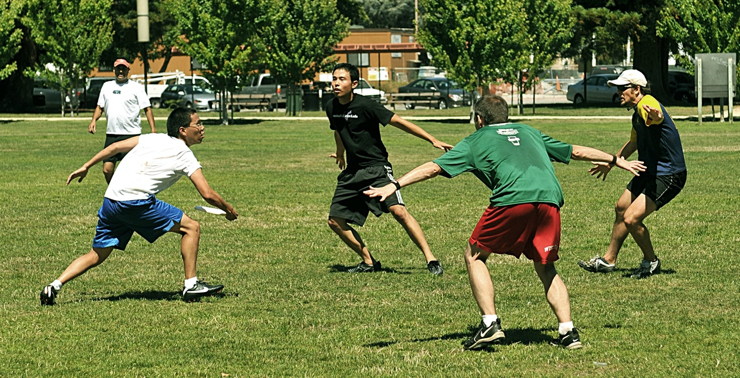

Explain three (3)immediate circulatory responses to physical activity that you would experience during a training session. Furthermore, discuss how the heart rate, ventilation rate and the stroke volume change following a 12-week training program and explain the contribution that each of these adaptations has on improving the athlete’s aerobic capacity.

|  |  |
| --- | --- |
| Description | Marks |
| Immediate circulatory responses – any 3 of the following   * Increased Heart Rate-   + Number of times heart beats per min   + To provide more rapid supply of fuel and energy to the muscles, heart rate increases during exercise * Increased Stroke Volume   + The amount of blood that is ejected from the left ventricle with each beat of the heart * Increased Blood Pressure   + Arterioles supplying working muscles vasodilate, so more blood is forced from arterioles into the capillaries surrounding the muscle   + More blood flow throughout the body creates increased pressure on the walls of the arteries * Increased Cardiac Output   + Total amount of blood the heart pumps every minute   + Increased HR and SV creates an increase in total blood circulation per minute * Blood Redistribution   + During exercise, arteries open up and contract to allow more or less blood to reach certain areas of the body. | 1 mark identify  1 mark explanation  Max 6 marks |

|  |  |
| --- | --- |
| Description | Marks |
| Heart Rate   * Resting heart rate is lower * Less rapid increase in heart rate with an increase in the intensity of exercise * Lower heart rate a sub maximal exercise | 1-2 |
| Contribution to increased aerobic capacity:   * The lower heart rate means that the athlete will reach their maximum heart rate at a higher intensity of exercise | 1 |
| Ventilation rate   * Efficiency of respiration is improved * Strength and endurance of the intercostal muscles (muscles involved in breathing) is improved * Trained individuals have a lower ventilation rate when exercising at sub maximal intensity * Trained individuals achieve a higher maximal rate of minute ventilation | 1-2 |
| Contribution to increased aerobic capacity:   * The higher ventilation rate results in a greater volume of air moving through the lungs. This results in increased diffusion of oxygen into the blood stream making more oxygen available to the working muscles | 1 |
| Stroke volume:   * Stroke volume increases at rest and during exercise * The size of the heart increases * The ventricle wall becomes thicker * The ventricle holds more blood | 1-2 |
| Contribution to increased aerobic capacity:   * Results in an increase in maximal cardiac output - larger volume of blood is distributed to the working muscles during maximal exercise | 1 |

**End of Section Three**

**ACKNOWLEDGEMENTS**

Question 17 Image of track

<https://www.needpix.com/photo/489211/running-track-running-track-run-exercise-sport-sprint-field-race>

Question 25 Image of triple jumper

<http://mil.ru/et/news/more.htm?id=12217599@egNews>

Question 27 Image of shot put

<https://www.needpix.com/photo/679438/athletics-ball-butt-sport-junior-gala-mannheim>

Question 31 Image of footballer

<https://commons.wikimedia.org/wiki/File:Tayla_Harris_kick_23.03.19.jpg>

Question 32 Image of ultimate frisbee

<https://en.wikipedia.org/wiki/Ultimate_(sport)>